Grade 7 Accelerated · Unit 5 · Lessons 8–9  Converting Mass, Area and Volume  Independent Set 5.08 ANSWER KEY | Name  Date  Period

Six questions, on your own, in silence. Show the step that does the work.
1. 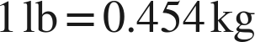. How many kilograms is 30 lb?
13.62 kg
(30 ÷ 2.204 = 13.61 by the other ratio.)

2. 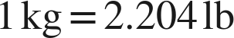. How many pounds is 25 kg?
55.1 lb

3. 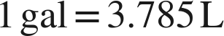. How many liters is 6 gal?
22.71 L

4. . How many square inches is 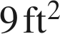?
1,296 in²
9 × 144: the ratio squared.

5.  and . How many liters is 24 fl oz?
0.72 L
3 c × 0.24.

6. . How many square meters is 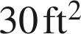? (Round to two places.)
About 2.79 m²
30 × 0.305²: the sheet's length ratio, squared, across systems.

